Software Design Document
AI-Assisted Software Development Efficiency Analyzer



Submitted by
Muhammad Anas (S23BINFT1M01019)

Submitted to
Mr. Zaman Ali

Department of Information Technology
Faculty of Computing
The Islamia University of Bahawalpur

Summery
This Software Design Document describes the internal design and architecture of the AI-Assisted Software Development Efficiency Analyzer. The purpose of this system is to track how developers use AI tools during coding sessions and measure the effect of that usage on their performance, productivity, and code quality.
The system is built using React.js on the frontend, Laravel as the backend framework, MySQL for the database, and the OpenAI GPT-4o API for the built-in AI assistant. Laravel Sanctum handles authentication, Monaco Editor provides the in-browser coding environment, and Chart.js is used for visualizing the analytics data.
This document covers the complete application architecture following the MVC pattern, explains the proposed controllers and their functions, and describes how the system's components interact with each other. The data model section details all eight MySQL tables, their columns, data types, and relationships. The user interface section documents the design philosophy, all major screens, their controls, and the input constraints on each page.
All required UML diagrams have been included in the relevant sections: System Context Diagram, DFD Level 0 and Level 1, Sequence Diagram, Activity Diagram, Component Diagram, Class Diagram, and Use Case Diagram.

Table of Content
- Application Architecture………………………………………………………..............1
  - Architecture Pattern ........................................................................................................... 1
  - List of Controllers and Their Functions ............................................................................. 2
1.2.1 AuthController ....................................................................................................... 2
1.2.2 TaskController ....................................................................................................... 2
1.2.3 SessionController ................................................................................................... 3
1.2.4 AnalyticsController .................................................................................................4
1.2.5 AIAssistantController .............................................................................................5
1.2.6 RecommendationController ....................................................................................5
1.2.7 AdminController .....................................................................................................6
1.3 External APIs and Libraries ...............................................................................................7
1.4 Coding Conventions ..........................................................................................................8
1.5 UML Diagrams ..................................................................................................................9
1.5.1 System Context Diagram ........................................................................................9
1.5.2 Data Flow Diagram (Level 0 and Level 1) .......................................................... 10
1.5.3 Sequence Diagram – AI-Assisted Coding Session .............................................. 11
1.5.4 Activity Diagram – Full System Workflow ......................................................... 12
1.5.5 Component Diagram ............................................................................................ 13
1.5.6 Class Diagram ...................................................................................................... 14
1.5.7 Use Case Diagram ............................................................................................... 15
- Data Model Schema ................................................................................................... 16
2.1 ER Diagram .................................................................................................................... 16
2.2 Table Descriptions .......................................................................................................... 17
2.2.1 users ..................................................................................................................... 17
2.2.2 tasks ..................................................................................................................... 18
2.2.3 task_assignments ................................................................................................. 19
2.2.4 sessions ................................................................................................................ 20
2.2.5 session_events ..................................................................................................... 21
2.2.6 session_metrics ................................................................................................... 22
2.2.7 recommendation_logs .......................................................................................... 23
2.2.8 analytics_profiles ................................................................................................ 24
- User Interface ........................................................................................................... 25
3.1 Design Philosophy and Interface Specifications ............................................................ 25
3.1.1 Color Scheme ...................................................................................................... 25
3.1.2 Typography ......................................................................................................... 26
3.1.3 Screen Layout Rules ............................................................................................26
3.2 List of Pages and Screen Descriptions ............................................................................27
3.2.1 Login / Registration Page .....................................................................................27
3.2.2 Developer Dashboard ...........................................................................................28
3.2.3 Coding Workspace ...............................................................................................28
3.2.4 Post-Session Results Page ................................................................................... 29
3.2.5 Performance Metrics Dashboard ......................................................................... 29
3.2.6 Skill Development Panel ..................................................................................... 30
3.2.7 Task Queue .......................................................................................................... 30
3.2.8 Administration Panel ........................................................................................... 31
3.3 Controls, Input Constraints, and Feedback ..................................................................... 32
Appendix A: Glossary .........................................................................................................33
References ............................................................................................................................34

- Application Architecture
The AI-Assisted Software Development Efficiency Analyzer follows the Model-View-Controller (MVC) architectural pattern. This made sense for this project because it cleanly separates the frontend React code from the backend Laravel logic, so changes on one side do not break the other. On the backend, Laravel handles all the application logic, API routing, and database operations. On the frontend, React builds the user interface and sends HTTP requests to the Laravel API.
The overall system is split into four main layers. The Presentation Layer is the React frontend running in the browser. The Application Layer is the Laravel backend which processes requests, runs the analytics, and talks to the AI. The Data Layer is the MySQL database. The External Layer covers the OpenAI GPT-4o API which the system calls whenever a developer sends a message to the AI assistant panel.

1.1 Architecture Pattern
The system uses MVC. In this project:
- Models — Laravel Eloquent models represent the database tables (User, Session, Task, Metric, etc.) and handle all database queries.
- Views — Not traditional server-rendered views. The React frontend acts as the view layer. It fetches data from the Laravel API and handles all the UI rendering.
- Controllers — Laravel controllers receive the API requests, run the business logic, and send back JSON responses to React.
This setup is sometimes called an API-first MVC because the backend only deals with data and logic, not with HTML rendering. It works well here because the React frontend and the Laravel API can be developed and tested separately.

1.2 List of Controllers and Their Functions
Below are the main Laravel controllers that handle the backend logic of this system. Models and Views are not explained here in detail as per the documentation requirements.

AuthController
Handles all authentication-related requests. It manages user registration, login, and logout using Laravel Sanctum for token-based API authentication.
Function | Description
register(Request $req) | Validates and stores a new user. Creates an empty analytics profile linked to the new account. Returns a Sanctum token on success.
login(Request $req) | Checks email and password against the database. If valid, generates and returns a Sanctum API token for the session.
logout(Request $req) | Revokes the current user's Sanctum token. The frontend clears its local token after this call.

TaskController
Manages everything related to coding tasks. Administrators use these endpoints to create and assign tasks. Developers use them to fetch tasks in their queue.
Function | Description
store(Request $req) | Creates a new task record in MySQL. Validates all required fields (title, description, difficulty, time limit, language). Sends a notification to each assigned developer.
index() | Returns the list of tasks assigned to the currently logged-in developer. Filtered by completion status.
show($id) | Returns full details for a single task. Used when a developer opens a task in the workspace.
update(Request $req, $id) | Lets the administrator edit an existing task's details or reassign it to different developers.
destroy($id) | Archives a task so it no longer appears in developer queues. Does not delete session records linked to it.

SessionController
Controls the lifecycle of a coding session from start to submission. Works together with the tracking module to save events in real time.
Function | Description
start(Request $req) | Creates a new session record in MySQL. Stores the start timestamp and links the session to the task and the developer. Starts the timer on the backend.
logEvent(Request $req) | Receives a single event from the frontend (AI prompt, code edit, run event, or error) and appends it to the session log. Called frequently during an active session.
submit(Request $req, $id) | Marks the session as submitted, stores the final code, logs the end timestamp, and triggers the AnalyticsController to run the efficiency analysis.
index() | Returns a list of all past sessions for the logged-in developer. Used by the dashboard to populate the history view.

AnalyticsController
This is the most important controller in the system. It processes the raw session data and computes all the performance metrics after a session is submitted.
Function | Description
analyse($sessionId) | Main entry point for the analytics pipeline. Calls each scoring function in order, then saves all results to the metrics table.
computePerformanceScore() | Calculates how fast the developer completed the task relative to the time limit. Produces a score out of 100 weighted at 30% of the final Efficiency Score.
computeProductivityScore() | Measures whether the submitted code is correct and how much of it represents meaningful work rather than boilerplate. Weighted at 30%.
computeCodeQualityScore() | Checks the submitted code for syntax errors, cyclomatic complexity, and readability indicators. Weighted at 20%.
computeAIDependencyScore() | Counts the total AI prompts in the session and classifies it as Low (0-3), Medium (4-8), or High (9+). Converts this to a score that contributes 20% to the Efficiency Score.
computeEfficiencyScore() | Runs the formula: Efficiency Score = Performance(30%) + Productivity(30%) + Code Quality(20%) + AI Balance(20%). Returns a value between 0 and 100.
getDashboardData($userId) | Returns all the metric data needed to populate the developer's dashboard. Includes per-session scores and trend summaries for Chart.js to render.

AIAssistantController
Handles all communication with the OpenAI GPT-4o API. Also applies the adaptive assistance logic based on the developer's skill level before sending a request to OpenAI.
Function | Description
sendPrompt(Request $req) | Main function called whenever a developer sends a message in the AI panel. Fetches the developer's skill level, builds the adaptive system prompt, calls the OpenAI API, and returns the response.
buildSystemPrompt($skillLevel) | Returns a short instruction string prepended to every API call. Beginner gets full step-by-step answers, Intermediate gets hints only, Expert gets a one-line nudge toward independent thinking.
logAIInteraction() | Saves the prompt text, the skill level used, the response timestamp, and the session ID to MySQL after each AI call.

RecommendationController
Generates the post-session feedback shown to the developer after the analytics engine finishes. Produces plain-language advice based on comparing the current session to past performance.
Function | Description
generate($sessionId) | Main function that pulls the current session metrics and the developer's historical averages, compares them, ranks the areas with the most room for improvement, and returns 3-5 feedback sentences.
compareToAverage() | Calculates how each metric in this session compares to the developer's running average. Returns the difference as a percentage.
buildFeedbackSentence() | Turns a metric comparison result into a short, readable sentence. For example: You used the AI 11 times on a Beginner task — try keeping it under 4 next time.

AdminController
Gives the System Administrator access to user management, task management, and platform-level reporting functions.
Function | Description
listUsers() | Returns all user accounts in the system. Supports filtering by role (Developer, Team Lead, Admin) and by active/inactive status.
updateUser(Request $req, $id) | Updates a user's role, resets their password, or changes their active status. All actions are logged in the audit table.
generatePlatformReport() | Pulls platform-wide stats: total sessions completed, average efficiency score, and AI dependency breakdown. Returns data for the admin dashboard.

1.3 External APIs and Libraries
The following external APIs and libraries are used by the system:
Name | Layer | How it is used
OpenAI GPT-4o API | Backend | Called by AIAssistantController whenever a developer sends a prompt. The response is returned to the React frontend and displayed in the AI panel.
Laravel Sanctum | Backend | Handles token-based API authentication between the React frontend and the Laravel API. Every protected route checks for a valid Sanctum token.
Monaco Editor | Frontend | Provides the in-browser code editor with syntax highlighting, autocomplete, and multi-language support. It is the core component of the coding workspace.
Chart.js | Frontend | Draws all the charts on the dashboard: Efficiency Score line chart, AI usage bar chart, Code Quality trend, and the scatter plot comparing performance and productivity.
Tailwind CSS | Frontend | Used for all UI styling. Provides utility classes that keep the interface consistent without needing a lot of custom CSS files.

1.4 Coding Conventions
- Laravel follows PSR-12 coding standards for PHP files throughout.
- Controller and Model class names use PascalCase (e.g., AnalyticsController, SessionLog).
- All function and variable names in both PHP and JavaScript use camelCase (e.g., computePerformanceScore, sessionStartTime).
- Database column names use snake_case (e.g., session_start_time, efficiency_score).
- React components are organized by feature in separate folders (e.g., /components/workspace, /components/dashboard).
- API routes are prefixed with /api/v1/ so the version can be updated without breaking old integrations.
- All API responses follow a standard JSON format: { status, message, data }.
- Environment variables (API keys, DB credentials) are kept in the .env file and never hardcoded.

1.5 UML Diagrams

1.5.1 System Context Diagram
The System Context Diagram below shows the AI-Assisted Software Development Efficiency Analyzer as the central system. On one side, the three types of users interact with it: the Developer, the Team Lead, and the System Administrator. On the other side, the system communicates with the OpenAI GPT-4o API. The MySQL database is part of the system boundary. The React frontend and Laravel backend are both inside the system rectangle.
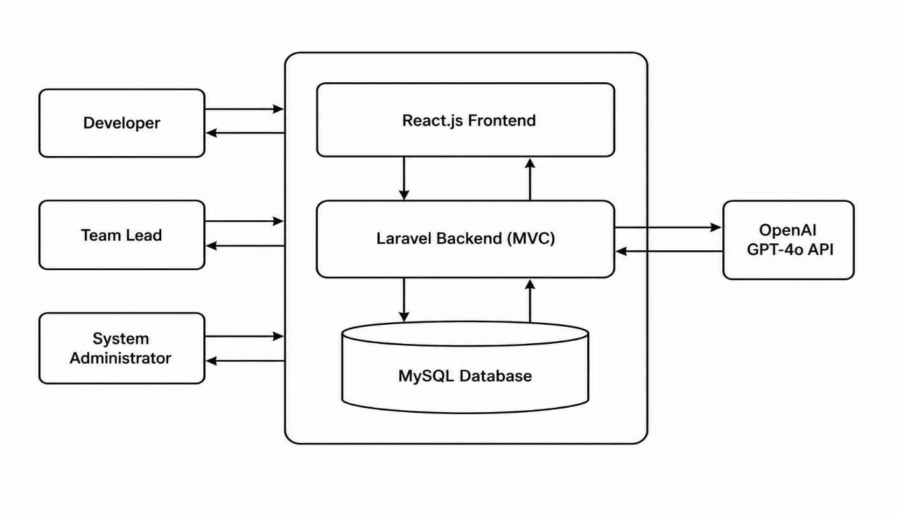

1.5.2 Data Flow Diagram (Level 0 and Level 1)
The DFD is provided at two levels. Level 0 shows the whole system as a single process that receives inputs from the developer (code, prompts, login credentials) and returns outputs (analytics results, AI responses, dashboard data.
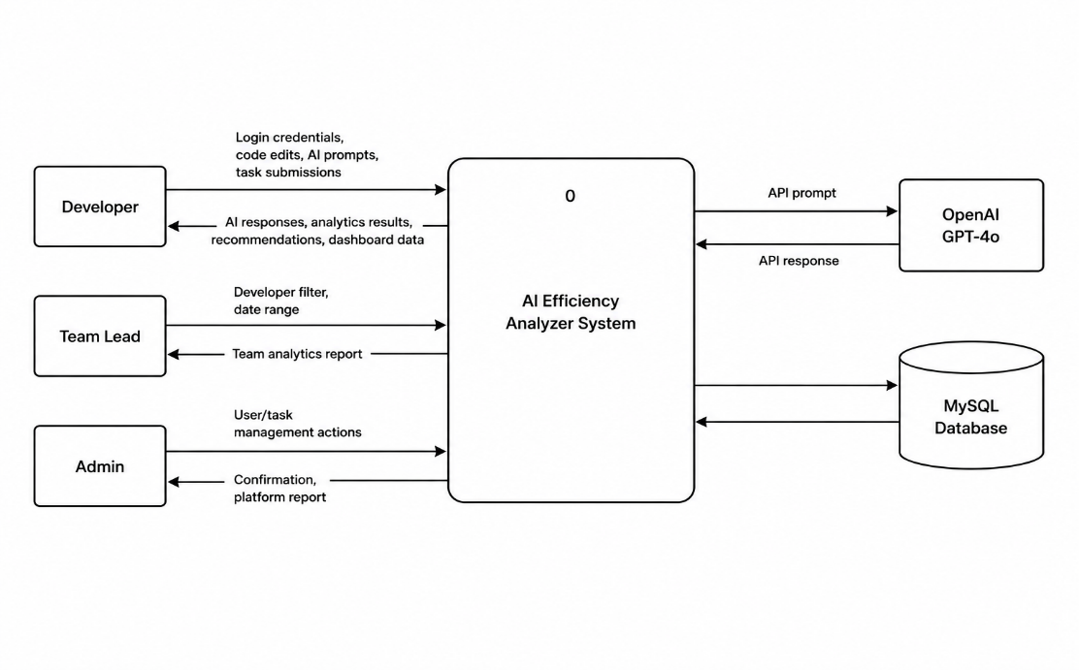
Level 1 breaks that single process into six sub-processes: User Authentication, Task Management, Coding Session Tracking, Analytics Engine, AI Assistant Handler, and Dashboard Renderer.

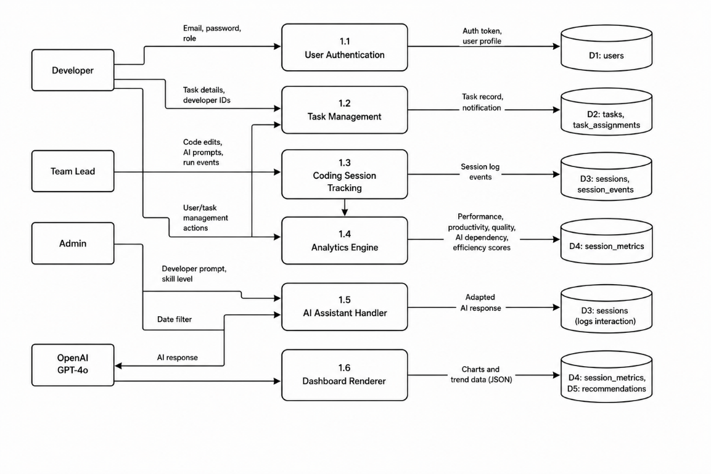

1.5.3 Sequence Diagram — AI-Assisted Coding Session
The Sequence Diagram below shows what happens from the moment a developer opens a task to the moment the analytics results are ready. Solid arrows represent calls and dashed arrows represent return messages. The main participants are: Developer, React Frontend, Laravel API, MySQL, and OpenAI GPT-4o API.

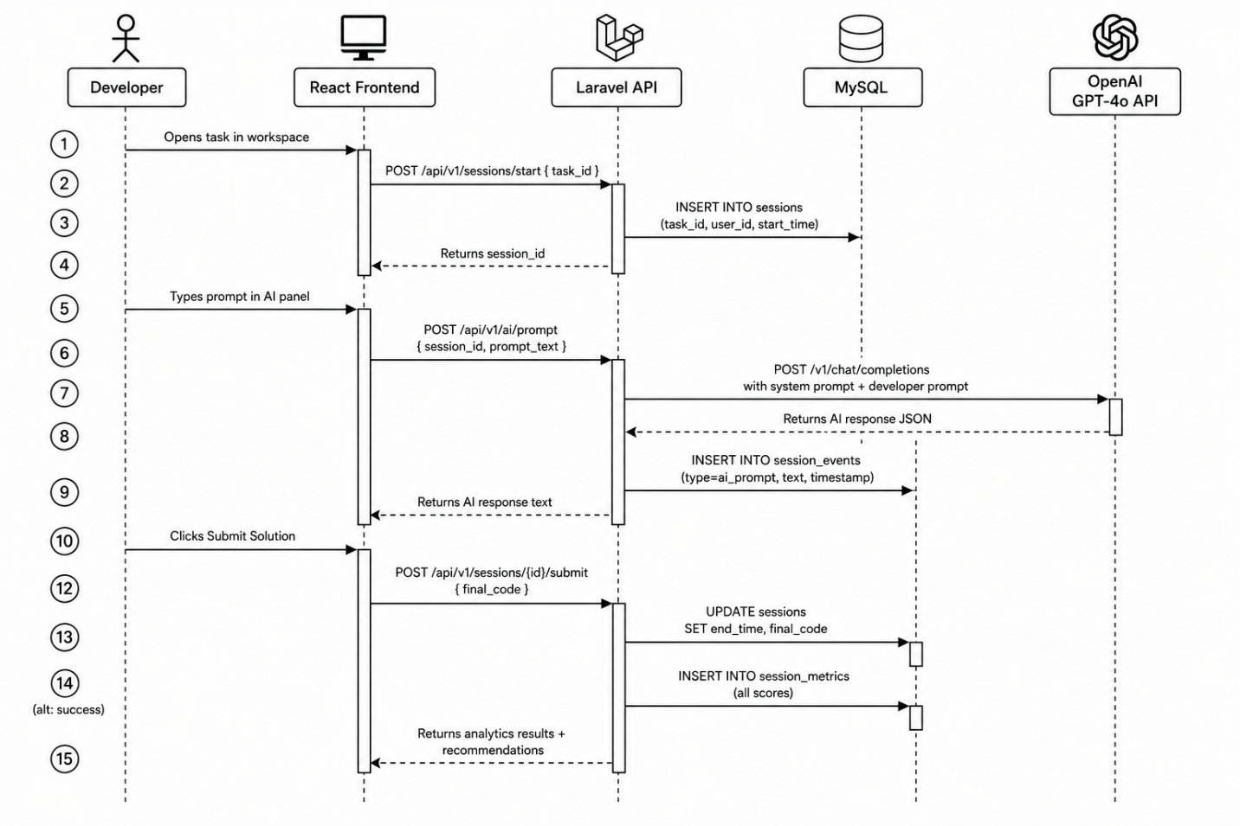

1.5.4 Activity Diagram — Full System Workflow
The Activity Diagram covers the complete control flow of the system from a developer logging in all the way to viewing recommendations after a session ends. Decision diamonds show two major branching points: whether the submitted code passes correctness checks, and whether the AI dependency level is High (which affects the recommendation engine output).

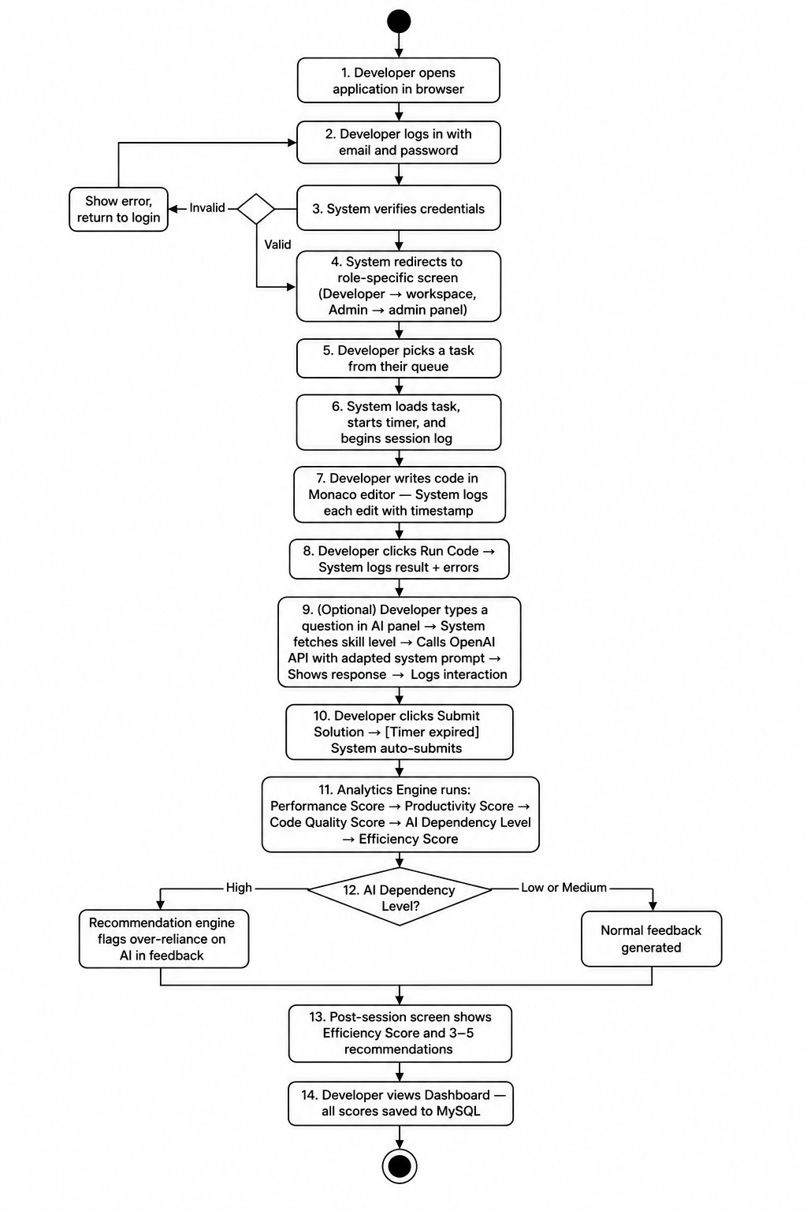

1.5.5 Component Diagram
The Component Diagram shows how the major parts of the system are organized and how they depend on each other. There are three main subsystems: the React Presentation Layer, the Laravel Application Layer, and the External Services. Arrows show the direction of calls and data flow between components.

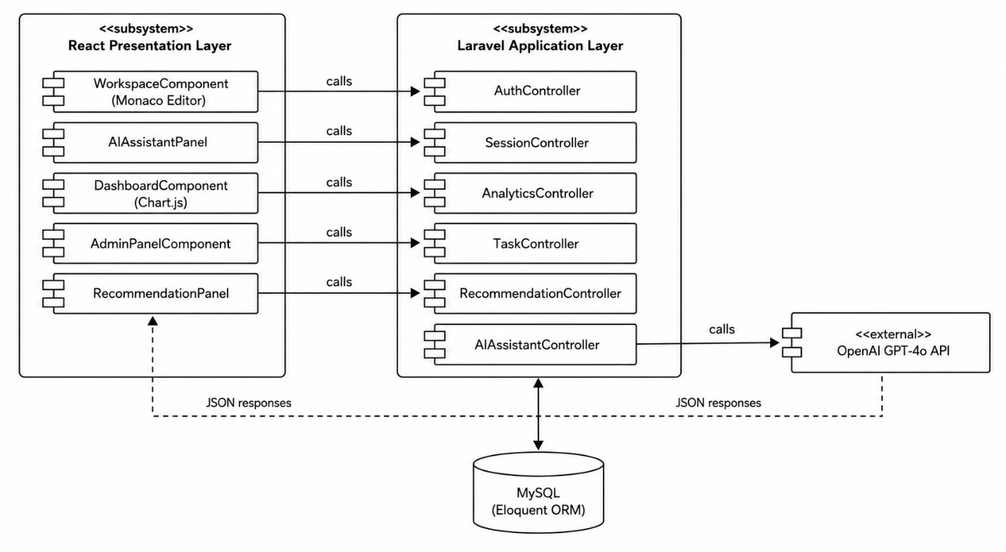

1.5.6 Class Diagram
The Class Diagram below shows the main classes in the system along with their attributes, methods, and relationships. The primary relationships shown are: Developer uses Session, Session produces SessionMetric, AnalyticsEngine reads Session and creates SessionMetric, Task is assigned to Developer, and RecommendationEngine reads SessionMetric.

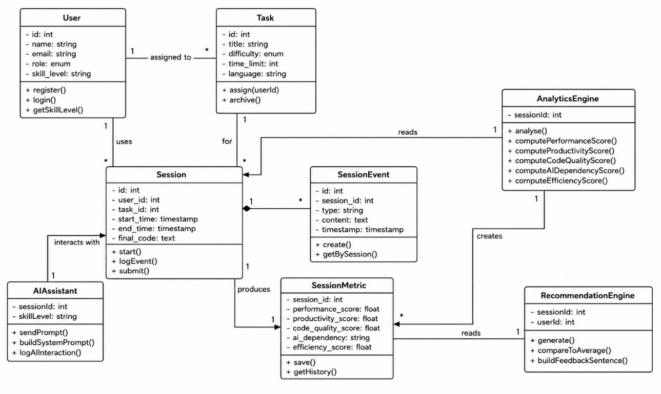

1.5.7 Use Case Diagram
The Use Case Diagram below shows all nine use cases of the system and which actors can trigger them. The three actors are the Developer, the Team Lead, and the System Administrator. The system also acts as its own actor for automated processes like session analysis and recommendation generation. Include and extend relationships are shown where one use case always triggers another, or where something happens only under a condition.
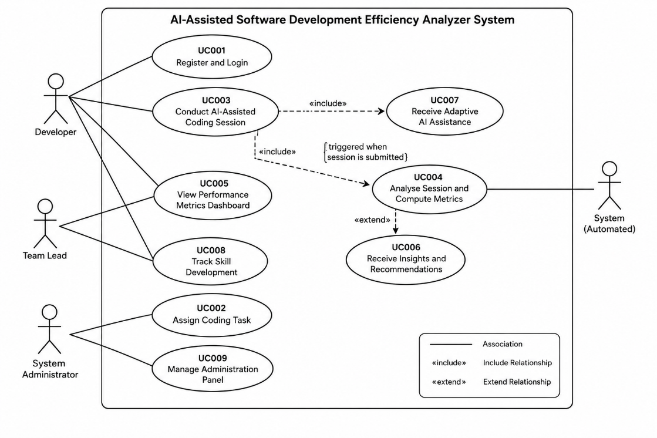
- Data Model Schema
All data in this system is stored in a MySQL relational database. The database is accessed through Laravel's Eloquent ORM which maps each table to a Model class. The schema is designed to be extensible so that new metric types or task categories can be added later without touching existing session records.

2.1 ER Diagram
The Entity Relationship Diagram below shows all eight tables in the database and how they are connected. Primary keys are marked with PK and foreign keys with FK. The main chain of relationships is: a User gets assigned Tasks, each Task produces Sessions, each Session has many SessionEvents, and each Session produces one SessionMetric. The RecommendationLog table stores the advice generated after each session.

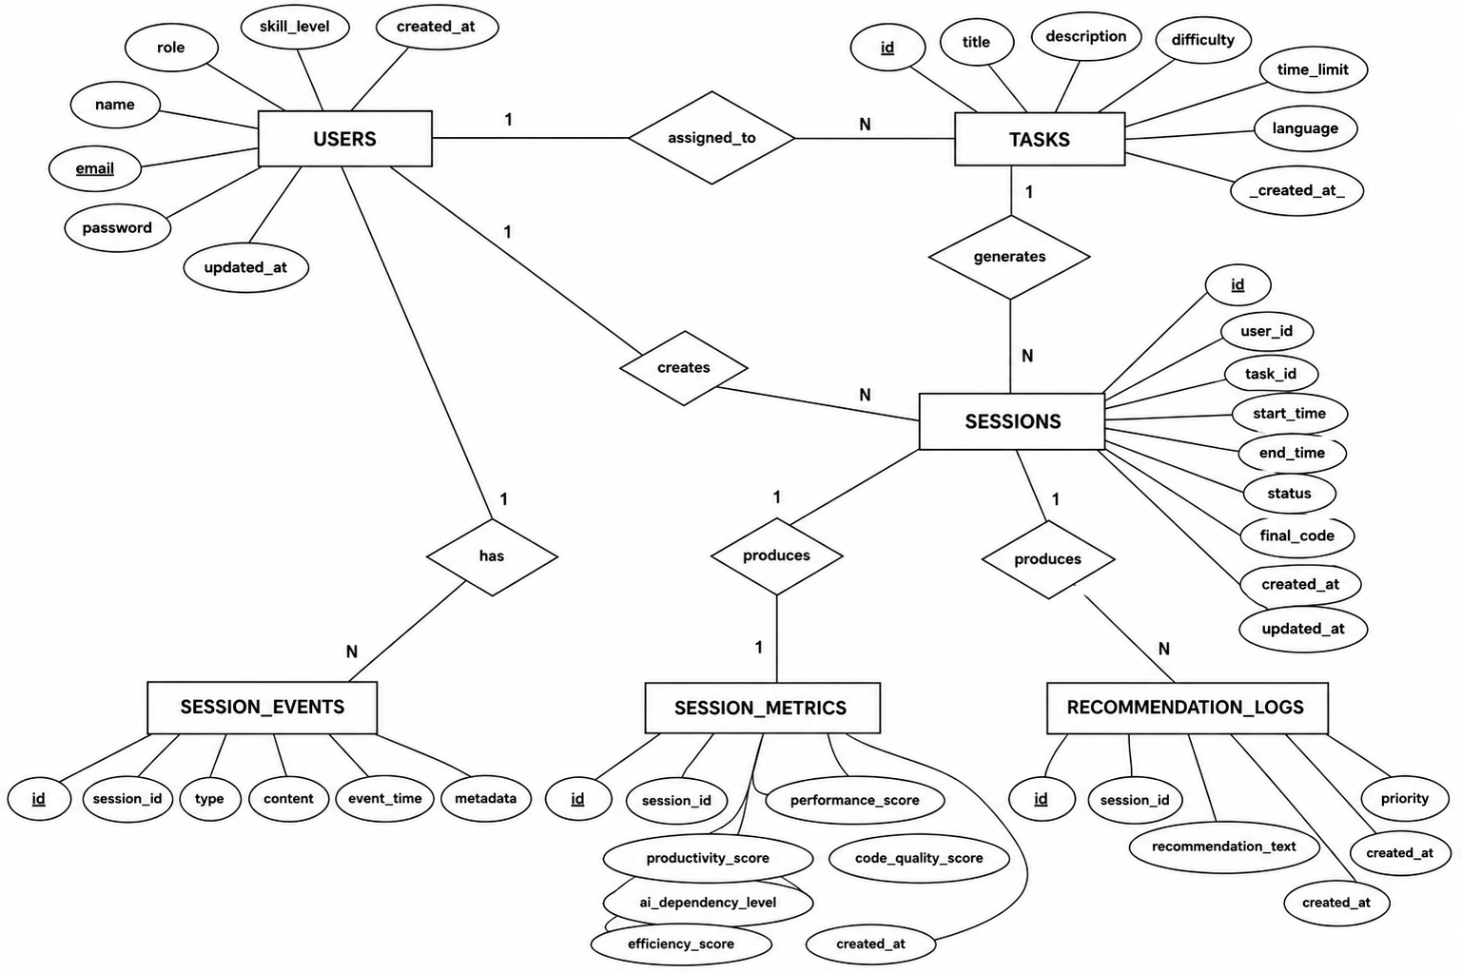

2.2 Table Descriptions

2.2.1 users
Stores all user accounts in the system regardless of their role. The role field controls what each user can see and do.
Column | Type | Constraint | Description
id | BIGINT | PK, AUTO_INCREMENT | Unique identifier for each user account.
name | VARCHAR(100) | NOT NULL | Full name of the user.
email | VARCHAR(150) | UNIQUE, NOT NULL | Email address used for login. Must be unique.
password | VARCHAR(255) | NOT NULL | Bcrypt-hashed password. Never stored as plain text.
role | ENUM | NOT NULL | One of: developer, team_lead, admin.
skill_level | ENUM | DEFAULT 'beginner' | Computed from session history: beginner, intermediate, or expert.
is_active | TINYINT(1) | DEFAULT 1 | 0 = deactivated account, 1 = active. Deactivated users cannot log in.
created_at | TIMESTAMP | DEFAULT NOW() | When the account was created.

2.2.2 tasks
Stores all coding tasks created by the administrator. Each task is a self-contained problem with a description, difficulty level, time limit, and required programming language.
Column | Type | Constraint | Description
id | BIGINT | PK, AUTO_INCREMENT | Unique task identifier.
title | VARCHAR(200) | NOT NULL | Short name for the task.
description | TEXT | NOT NULL | Full problem statement with input/output specification.
difficulty | ENUM | NOT NULL | One of: beginner, intermediate, advanced.
time_limit | INT | NOT NULL | Maximum time allowed in minutes. Enforced by the timer on the session.
language | VARCHAR(50) | NOT NULL | Required programming language (e.g., python, javascript, php).
created_by | BIGINT | FK → users.id | The admin account that created this task.
is_archived | TINYINT(1) | DEFAULT 0 | 1 = task no longer visible to developers.
created_at | TIMESTAMP | DEFAULT NOW() | When the task was created.

2.2.3 task_assignments
A junction table that tracks which tasks are assigned to which developers. One task can be assigned to multiple developers and one developer can have multiple tasks.
Column | Type | Constraint | Description
id | BIGINT | PK, AUTO_INCREMENT | Unique record identifier.
task_id | BIGINT | FK → tasks.id | Links to the assigned task.
user_id | BIGINT | FK → users.id | Links to the developer the task is assigned to.
assigned_at | TIMESTAMP | DEFAULT NOW() | When the administrator made this assignment.
status | ENUM | DEFAULT 'pending' | One of: pending, in_progress, completed.

2.2.4 sessions
Records each time a developer works on a task. One session is created when a task is opened and closed when it is submitted or the timer runs out.
Column | Type | Constraint | Description
id | BIGINT | PK, AUTO_INCREMENT | Unique session identifier.
user_id | BIGINT | FK → users.id | The developer who ran this session.
task_id | BIGINT | FK → tasks.id | The task this session is for.
start_time | TIMESTAMP | NOT NULL | When the developer opened the task and the timer started.
end_time | TIMESTAMP | NULLABLE | When the session was submitted or timed out. NULL if still in progress.
final_code | TEXT | NULLABLE | The last version of the code the developer submitted.
is_timed_out | TINYINT(1) | DEFAULT 0 | 1 = session ended because the timer ran out, not by the developer's choice.
is_partial | TINYINT(1) | DEFAULT 0 | 1 = analytics could only be partially computed due to a missing log event.

2.2.5 session_events
This is the core tracking table. Every event that happens during a session is stored here as a separate row with a type, content, and timestamp. The analytics engine reads this table to compute all the scores.
Column | Type | Constraint | Description
id | BIGINT | PK, AUTO_INCREMENT | Unique event identifier.
session_id | BIGINT | FK → sessions.id | Links this event to a session.
event_type | ENUM | NOT NULL | One of: code_edit, ai_prompt, ai_response, run_code, run_error.
event_content | TEXT | NULLABLE | The actual text of the event. For ai_prompt, this is what the developer typed.
ai_skill_level | VARCHAR(20) | NULLABLE | For AI prompt events: the skill level that was used to build the system prompt.
timestamp | TIMESTAMP | NOT NULL | Exactly when this event occurred.

2.2.6 session_metrics
Stores the output of the analytics engine for each completed session. One row per session. All five computed scores are saved here.
Column | Type | Constraint | Description
id | BIGINT | PK, AUTO_INCREMENT | Unique metrics record identifier.
session_id | BIGINT | FK → sessions.id, UNIQUE | Links to the session this metric set belongs to. One-to-one.
performance_score | DECIMAL(5,2) | NOT NULL | How fast the developer completed the task vs. the time limit. Weighted 30%.
productivity_score | DECIMAL(5,2) | NOT NULL | Code correctness and amount of meaningful code produced. Weighted 30%.
code_quality_score | DECIMAL(5,2) | NOT NULL | Syntax errors, cyclomatic complexity, and readability. Weighted 20%.
ai_dependency_level | ENUM | NOT NULL | Low (0-3 prompts), Medium (4-8), or High (9+).
ai_dependency_score | DECIMAL(5,2) | NOT NULL | Numeric equivalent of the dependency level. Weighted 20% in the efficiency formula.
efficiency_score | DECIMAL(5,2) | NOT NULL | Final combined score: Performance(30%) + Productivity(30%) + Code Quality(20%) + AI Balance(20%). Range: 0–100.
computed_at | TIMESTAMP | DEFAULT NOW() | When the analytics engine finished running.

2.2.7 recommendation_logs
Stores the feedback items generated by the recommendation engine after each session. Each feedback item is a separate row linked to the session.
Column | Type | Constraint | Description
id | BIGINT | PK, AUTO_INCREMENT | Unique recommendation identifier.
session_id | BIGINT | FK → sessions.id | Links to the session this feedback was generated for.
user_id | BIGINT | FK → users.id | The developer the feedback belongs to.
feedback_text | TEXT | NOT NULL | The actual feedback sentence shown to the developer.
priority | TINYINT | NOT NULL | Order of importance (1 = most important). Used to sort feedback on the screen.
created_at | TIMESTAMP | DEFAULT NOW() | When this feedback was generated.

2.2.8 analytics_profiles
Stores the running averages and summary statistics for each developer. This table is updated after every session and is what the recommendation engine uses to compare a developer's latest performance to their own history.
Column | Type | Constraint | Description
id | BIGINT | PK, AUTO_INCREMENT | Unique profile identifier.
user_id | BIGINT | FK → users.id, UNIQUE | One profile per developer account.
avg_efficiency_score | DECIMAL(5,2) | DEFAULT 0 | Running average of all Efficiency Scores across all sessions.
avg_ai_dependency | DECIMAL(5,2) | DEFAULT 0 | Running average AI prompts per session.
total_sessions | INT | DEFAULT 0 | Total number of sessions completed by this developer.
skill_growth_index | DECIMAL(5,2) | DEFAULT 0 | A single number summarizing how much the developer has improved overall.
updated_at | TIMESTAMP | ON UPDATE NOW() | Automatically updated every time a new session is analysed.

- User Interface
AI-Assisted Software Development Efficiency Analyzer is a browser-based web application. The frontend is built in React.js with Tailwind CSS for styling. The interface is designed for desktop screens — a minimum width of 1280 pixels is assumed. The layout is not adapted for mobile devices. All primary navigation happens through a persistent top bar, and most content areas use a two-column or three-column grid depending on the page.

3.1 Design Philosophy and Interface Specifications

3.1.1 Color Scheme
The system uses a professional, clean color palette that avoids distracting the developer from the task they are working on:
Color Role | Hex Value | Where It Is Used
Primary / Brand | #1D4ED8 (Blue) | Navigation bar, primary action buttons, active menu items.
Background | #F9FAFB (Light Grey) | Main content area background across all pages.
Card Background | #FFFFFF (White) | Content cards, panels, the Monaco editor background.
Success / Positive | #16A34A (Green) | Correct code run results, High Efficiency scores, positive metric deltas.
Warning / Medium | #CA8A04 (Amber) | Medium AI dependency labels, moderate efficiency scores.
Danger / Alert | #DC2626 (Red) | High AI dependency flag, code errors, failed test results.
Text — Primary | #111827 (Near Black) | All main body text across the application.
Text — Secondary | #6B7280 (Grey) | Captions, timestamps, metadata labels.

3.1.2 Typography
- Font Family: Inter (Google Fonts). Falls back to sans-serif if unavailable.
- Page titles: 24px, bold.
- Section headings: 18px, semi-bold.
- Body text: 14px, regular.
- Code inside Monaco Editor: JetBrains Mono, 14px — Monaco Editor manages this internally.
- Metric numbers on dashboard cards: 32px, bold, color varies by score level.

3.1.3 Screen Layout Rules
- Minimum supported screen width: 1280px.
- Navigation bar is always visible at the top of every page.
- Content areas use Tailwind's grid system: two-column layout for the workspace and most dashboard pages, three-column layout for the post-session recommendations screen.
- All data tables use the same card style: white background, 1px grey border, 8px border radius, 16px padding.
- Buttons follow a consistent size: primary actions are full-width inside their panel, secondary actions are auto-width.

3.2 List of Pages and Screen Descriptions

3.2.1 Login / Registration Page
This is the first page any user sees. The layout is centered, with a white card in the middle of a blue gradient background. There are two tabs: Login and Register. The Register tab collects name, email, password, confirm password, and a role dropdown. The Login tab just takes email and password. Validation error messages appear inline below each input field.

3.2.2 Developer Dashboard
The main landing page for developers after login. Shows a summary of recent performance across three metric cards at the top: Latest Efficiency Score, AI Dependency Level, and Average Code Quality. Below that there are two Chart.js graphs: an Efficiency Score trend line covering the last 30 sessions and a bar chart showing AI prompt counts per session. A Recent Sessions table below the charts lists the five most recent sessions with their date, task name, and scores.

3.2.3 Coding Workspace
This is the core page of the application. It is split into two panels. The left panel contains the Monaco Editor where the developer writes code, a Run Code button at the bottom, a terminal-style output area below the editor showing run results and errors, and the task description visible in a collapsible card at the top. The right panel contains the AI Assistant panel — a scrollable message thread where the developer's prompts appear on one side and the AI responses appear on the other, styled like a chat interface. Below the thread there is a text input and a Send button. A countdown timer is always visible in the top right. A Submit Solution button is fixed at the bottom right of the page.

3.2.4 Post-Session Results Page
Shown immediately after the developer submits a solution. The top section shows four large metric cards: Performance Score, Productivity Score, Code Quality Score, and Efficiency Score, each with a colored indicator showing whether it improved or dropped compared to the developer's average. The AI Dependency Level is shown as a badge (Low, Medium, or High) with a color matching the color scheme. Below the scores, there is a Recommendations section showing three to five feedback items as plain text cards, ordered from most to least important. A View Full Dashboard link is at the bottom.

3.2.5 Performance Metrics Dashboard
A detailed analytics view accessible from the navigation bar. The top row has filter controls: a date range picker, a metric selector dropdown, and for Team Leads only, a developer selector dropdown. The main area has four Chart.js visualizations: an Efficiency Score line chart, an AI usage bar chart, a Code Quality trend line, and a scatter plot comparing performance against productivity. An Export Report button in the top right downloads a PDF summary.

3.2.6 Skill Development Panel
Accessible from the dashboard. Shows four trend lines: coding speed over time, error count over time, AI dependency over time, and code quality over time. An overall Skill Growth Index card is shown at the top. If fewer than three sessions exist, the page shows: Complete at least 3 sessions to unlock your Skill Development report.

3.2.7 Task Queue
Lists all tasks assigned to the developer with their status (Pending, In Progress, Completed) and a Start Task button for pending ones. Completed tasks show their final Efficiency Score. The administrator sees this page as the Task Management panel where they can create, edit, assign, and archive tasks.

3.2.8 Administration Panel
Only accessible to System Administrator accounts. Split into three sections accessible via a side tab: Users, Tasks, and Platform Report. The Users section shows a filterable table of all accounts with Edit, Deactivate, and Reset Password options. The Tasks section mirrors the task creation and assignment workflow. The Platform Report section shows total sessions, average efficiency score across all developers, and a breakdown of AI dependency levels as a pie chart.

3.3 Controls, Input Constraints, and Feedback
Control | Location | Constraints and Feedback Behaviour
Email Input | Login / Register Page | Must match standard email format. If invalid: 'Please enter a valid email address' shown below the field.
Password Input | Registration Page | Minimum 8 characters, must include at least one number and one special character. Strength indicator shown below the field.
Role Dropdown | Registration Page | Options: Developer, Team Lead, System Administrator. Selection is required. Cannot be changed by the user after account creation.
Monaco Editor | Coding Workspace | Accepts any text input. Language mode set automatically based on the task's required language. No character limit.
Run Code Button | Coding Workspace | Disabled for the first 2 seconds after a run to prevent spam. Shows a spinner while executing. Output appears in the terminal panel below.
AI Prompt Input | AI Assistant Panel | Text area with a 500-character limit per message. Send button disabled when empty. If OpenAI API is unavailable: 'AI assistant is currently unavailable, please try again shortly.'
Submit Solution Button | Coding Workspace | Triggers a confirmation dialog: 'Are you sure you want to submit? You cannot edit your code after this.' Cancel returns to the editor.
Date Range Picker | Dashboard | Two calendar inputs: Start Date and End Date. End Date cannot be before Start Date. If no sessions exist for the range: 'No data available for the selected period.'
Export Report Button | Dashboard | Generates a PDF of the currently filtered dashboard data. Download starts automatically. Button shows 'Generating...' while processing.
Task Title Input | Admin Task Creation | Maximum 200 characters. Required. Shown in the developer's task queue.
Time Limit Input | Admin Task Creation | Numeric input. Minimum value: 5 minutes. Maximum: 240 minutes. Non-integer values not accepted.
Developer Selector (Team Lead) | Dashboard | Multi-select dropdown listing all Developer accounts in the Team Lead's group. Deactivated accounts shown in grey but selectable for historical data.

Appendix A: Glossary
- AI-Assisted Software Development Efficiency Analyzer: The full name of this Final Year Project system.
- MVC (Model-View-Controller): The architectural pattern used in this project. Laravel handles Model and Controller, React handles View.
- Laravel: A PHP web framework used for building the backend API and business logic of this system.
- React.js: A JavaScript library used to build the frontend user interface.
- Monaco Editor: The open-source code editor component (same engine as VS Code) embedded in the coding workspace.
- Laravel Sanctum: A lightweight authentication package for Laravel that manages API tokens.
- GPT-4o: The OpenAI model used by the AI assistant panel in this system.
- Efficiency Score: The final combined metric computed by the analytics engine. Formula: Performance(30%) + Productivity(30%) + Code Quality(20%) + AI Balance(20%).
- AI Dependency Level: A classification of how many AI prompts a developer used in a session. Low = 0-3 prompts, Medium = 4-8, High = 9+.
- Skill Growth Index: A single number summarizing overall improvement trend across all sessions for a developer.
- Session: One recorded instance of a developer working on a task. Starts when a task is opened and ends on submission or timeout.
- SessionEvent: A single logged interaction during a session (code edit, AI prompt, run event, or error).
- Session Metric: The computed analytics results stored after a session finishes.
- Chart.js: A JavaScript library used to render the charts and graphs on the dashboard.
- Adaptive AI Assistance: The feature that adjusts AI response detail level based on the developer's skill level profile.

References
[1] P. Vaithilingam, T. Zhang, and E. L. Glassman, "Expectation vs. Experience: Evaluating the Usability of Code Generation Tools Powered by Large Language Models," in Extended Abstracts of the 2022 CHI Conference on Human Factors in Computing Systems, ACM, 2022.
[2] A. Ziegler et al., "Measuring GitHub Copilot's Impact on Productivity," Communications of the ACM, vol. 67, no. 3, pp. 54-63, 2024.
[3] GitHub, Inc., "GitHub Copilot — Your AI pair programmer," [Online]. Available: https://github.com/features/copilot
[4] OpenAI, "OpenAI API Documentation," 2024. [Online]. Available: https://platform.openai.com/docs
[5] Laravel LLC, "Laravel — The PHP Framework for Web Artisans," 2024. [Online]. Available: https://laravel.com
[6] Meta Open Source, "React — A JavaScript library for building user interfaces," 2024. [Online]. Available: https://react.dev
[7] Microsoft Corporation, "Monaco Editor," GitHub Repository, 2023. [Online]. Available: https://github.com/microsoft/monaco-editor
[8] M. A. Siddiqui and R. Ahmed, "Measuring Developer Productivity in AI-Augmented Environments," IEEE Transactions on Software Engineering, vol. 49, no. 4, pp. 1823-1840, 2023.
[9] Oracle Corporation, "MySQL 8.0 Reference Manual," 2024. [Online]. Available: https://dev.mysql.com/doc
[10] IEEE Std 1016-2009, IEEE Standard for Information Technology Systems Design — Software Design Descriptions, IEEE Computer Society, 2009.

